# **Project Milestone (Sprint 5): MVP**

For this milestone we submitted our project zip file to canvas and updated our project repository on Github as well as our backlog. We have attached screenshots of both below:

**Trello Board (As of 4/18/2021)**

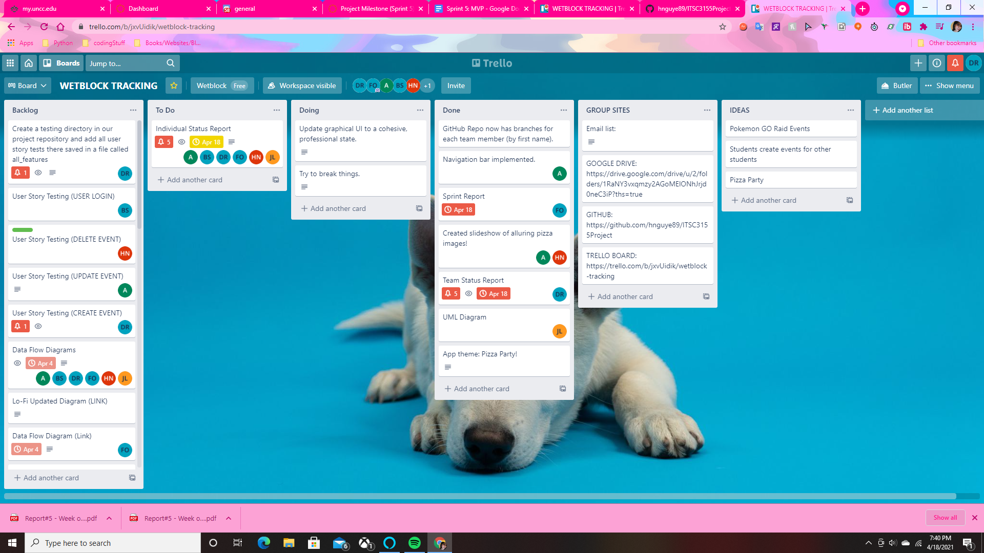

**Github Repository (As of 4/18/2021)**

